**FILE SHRAING IN IOT ENHANCED CLOUD COMPUTING**

**A PROJECT REPORT**

**Submitted by**

**AKILA D (810015104005)**

**SARMILA N.R (810015104082)**

**In partial fulfillment for the award of the degree**

**Of**

**BACHELOR OF ENGINEERING**

**IN**

**COMPUTER SCIENCE AND ENGINEERING**



**DEPARTMENT OF COMPUTER SCIENCE AND ENGINEERING**

**UNIVERSITY COLLEGE OF ENGINEERING-BIT CAMPUS**

**ANNA UNIVERSITY TIRUCHIRAPPLLI**

**ANNA UNIVERSITY::CHENNAI 600 025**

**APRIL 2019**

**UNIVERSITY COLLEGE OF ENGINEERING,**

**BIT CAMPUS,**

**TIRUCHIRAPPALLI-620024**

**BONAFIDE CERTIFICATE**

Certified that this project report titled “**FILE TRANSFER IN IOT ENHANCED CLOUD COMPUTING”** is a bonafide work of **AKILA D (810015104005) & SARMILA N R (810015104082)** who carried out the workunder my supervision, for the partial fulfillment of the requirements for the award of the degree of Bachelor of Engineering in computer science Certified further that to the best of my knowledge and belief, the work reported herein does not form part of any other thesis or dissertation on the basis of which a degree or an award was conferred on an earlier occasion.

**SIGNATURE SIGNATURE**

**Mr .D. Venkatesan Mr.S.Anuvelavan**

**HEAD OF THE DEPARTMENT ASSITANT PROFESSOR**

**DEPARTMENT OF CSE DEPARTMENT OF CSE**

University College of Engineering University College of Engineering

Anna University-BIT Campus Anna University-BIT Campus

Tiruchirappalli - 620024 Tiruchirappalli - 620024

Submitted for the project VIVA\_VOICE Examination held on…………………..

Internal Examinor External Examinor

**DECLRATION**

I hereby declare that the work entitled **“FILE TRANSFER IN IOT ENHANCED CLOULD COMPUTING”** is submitted in partial fulfillment of the requirements for the awardof the degree in B.E , in University College of Engineering, BIT Campus, Anna University**,** Tiruchirappalli . It is record of the our own work carried out by us during the academic year 2018-2019 under the supervision and guidance of **Mr. S. Anuvelavan** , Assistant Professor, Department of Computer Science and Engineering, BIT Campus, Anna University, Tiruchirappalli. The extent and source of information are derived from the existing literature and have been indicated through the dissertation at the appropriate places. The matter embodied in this work is original and has not been submitted for the award of any other degree, either in this or any other university.

AKILA D (810015104005)

SARMILA N R (810015104082)

I certify that the declaration made above by the candidate is true.

Signature of the Guide,

Mr. S. Anuvelavan,

Assistant professor,

Department of CSE/IT

University College Engineering,

Anna University-BITCampus,

Tiruchirappalli- 620024

**ACKNOWLEDGEMENT**

We would like to thank our honorable Dean **Dr. T. SENTHIL KUMAR**, Professor for having provided us with all required facilities to complete our project without hurdles.

We would also like to express our sincere thanks to **Mr.D.VENKATESAN**, Head of the Department of Computer Science and Engineering, for his valuable guidance, suggestions and constant encouragement paved way for the successful completion of this project work.

We would like to thank our Project Coordinator **Mr.C.SANKARRAM,** Assistant Professor **Mr.P.KARTHIKEYAN,** Assistant Professor **Mr.CSURESH KUMAR**, Teaching Fellow, Department of Computer Science for her kind support.

We would like to thank and express our deep sense of gratitude to our project guide, **Mr. S. ANUVELAVAN,** Assistant Professor, Department of Computer Science and Engineering, Anna University, Chennai, for his valuable guidance throughout the project.

We also extend our thanks to all other teaching and non-teaching staff for their encouragement and support.We thank our beloved parents and friends for their full support in the moral development of this project.

**ABSTRACT**

Web based file sharing and storage has recently became a necessary part of everyday data on the Enterprise level is needed to be stored in such a way that it can be retrieved easily from anywhere. This is the main concept of cloud computing & storage. Cloud computing has revolutionized the software industry, as the storage capacity on the internet is virtually infinite and it is most suited for enterprises to store and backup their vast life for every individual. Not only on the individual level but also amounts of data. One of the special and amazing feature of cloud storage is data synchronization. This allows the data to be synchronized i.e. mirrored on different platforms automatically. Another important concept is of web based connectivity of objects embedded with Electronics, Software and Sensors known as Internet of Things (loT). We have targeted the two main needs of an enterprise i.e. Data management, Security. Different modules are designed for this purpose. A Desktop Application and an Android Application is designed for data synchronization. Live video streaming feature is also included in the Website for security and surveillance purposes.

**TABL E OF CONTENTS**

**CHAPTER NO TITLE PAGE NO**

**ABSTRACT i**

**LIST OF FIGURES ii**

**LIST OF ABBREVATIONS iii**

**1 INTRODUCTION 1**

1.1 BACKGROUND AND MOTIVATION

1.1.1 CLOUD COMPUTING

1.2 INTERNET OF THINGS 3

1.3 WEB SERVER 5

1.4 RASPBERRY PI 6

**2 LITERATURE SURVEY** 9

**3 SYSTEM ANALYSIS** 14

3.1 EXISTING SYSTEM

3.2 PROPOSED SYSTEM

**4 SYSTEM DESIGN** 19

4.1 SYSTEM ARCHITECTURE

4.2 ARCHITECTURE EXPLNATION

**5 UML DIAGRAMS** 21

5.1 USECASE DIAGRAM

5.2 COLLABORATIVE DIAGRAM

5.3 SEQUENCE DIAGRAM

5.4 ACTIVITY DIAGRAM

**6 SYSTEM REQUIREMENTS** 26

6.1 HARDWARE REQUIREMENTS

6.2 SOFTWARE REQUIREMENTS

**7 SYSTEM IMPLEMENTATION** 27

7.1 MODULE S SPEIFICATONS

7.2 MODULE DESCRIPTION

**8 SOFTWARE SPECFICATION** 29

**9 RESULT & DICUSSION** 41

**10 CONCLUSION** 46

**11 REFERENCES** 47

**LIST OF FIGURES**

**FIGURE NO NAME OF THE FIGURE PAGE NO**

1.4.1 Raspberry Pi 3 MicroSD Card Slot  7

3.2.1 Architecture Diagram 18

4.1.1 Architecture Diagram 19

5.1.1 Use case Diagram 22

5.2.1 Activity Diagram 23

5.3.2 Collabarative Diagram for Staff 24

5.3.3 Collabarative Diagram for Student 25

5.4.1 Interaction Diagram for files upload 25

5.4.2 Interaction Diagram for files download 26

8.1 Working module of session 36

9.1 Screenshots 41

**ii**

**LIST OF ABBREVATIONS**

**ABBREVATIONS EXPANSION**

**s** IOT Internet of Things

API Application programming

Interface

PHP Hypertext Preprocessor

SQL Structure Query Language

XAMPP Cross-Platform(x),Apache(A),

MySQL(M), PHP(P), Perl(P)

VPN Virtual Private Network

iii

**CHAPTER 1**

**INTRODUCTION**

* 1. **Background and Motivation**

Intranets typically look like a private version of the internet. They use HTTP or other internet protocols to share information and computing resources. Here the new system frame work is created to share the local files through intranet. This is achieved by creating IoT computing environment that includes raspberry pi and cloud based services,

**1.1.1 Cloud Computing**

Cloud computing is developed based on the increasing demand of Internet using, interacting and other related aspects; it usually involves providing dynamic expand Internet service by virtualized resources. The cloud is a metaphor for describing networks or Internet. In the past pictures of clouds are often used to represent telecommunication network, and then it is also used to refer to abstraction of the Internet and the underlying infrastructure. The narrow cloud computing concept refers to the rent and use mode of IT infrastructure. It indicates the needed resources are obtained through the network, based on rules like on-demand and easy to expand; Generalized cloud computing refers to the rent and use mode of computing. This kind of service can be IT, software, Internet related, or other services. It means computational ability can be treated as a kind of commodity and be traded through the Internet just like other utilities such as water, gas, electricity and so on. Cloud computing has the following main features:

1) Dynamic resource allocation. According to the real time demand of consumers, cloud could dynamically divide or release different physical and virtual resources. When a request is raised, cloud would match it rapidly by increasing the available resources to realize elasticity of resources. If the user no longer needs this part of the resources, it can release these resources for free. Thus, cloud computing is regarded as infinite resources combined together which realizes the scalability of IT resources.

2) On demand self-service. Cloud computing provides a self-service mode as resources service, users can get resources automatically without interacting with providers. At the same time, the cloud system provides a certain application service directory; the customer can select the right service to meet their own needs. Convenience of network access. Users may access the network through different terminal equipment which makes the network accessible from anywhere.

3) Measurable service. In cloud computing, according to different types of services, resources can be automatically controlled and the allocation is optimized. It is a kind of pay-as-you-go service model.

4) Virtualization. With the virtualization technology, it is possible to reorganize computing resources distributed in different areas for realizing the sharing of infrastructure

Nowadays, cloud computing is rapidly developed and known by more and more people due to its advantages such as high scalability, high flexibility and low operational cost. Cloud service users usually do not need to know how the cloud based software or platform runs; instead, they only need to send the requests to the cloud provider and then wait for the results, which is a much easier and more efficient way to access the needed computing resources . However, there are several issues for the current cloud platforms. According to Ref. [2], security issues such as information leakage, unreliable data and unauthorized access are the most concerning problems by the majority of cloud users. Other issues such as stable operations, support systems and user friendliness have received less attention.

**1.2 Internet of Things**

The Internet of things (IoT) refers to the concept of extending Internet connectivity beyond conventional computing platforms such as personal computers and mobile devices, and into any range of traditionally "dumb" or non-internet-enabled physical devices and everyday objects. Embedded with electronics, Internet connectivity, and other forms of hardware (such as sensors), these devices can communicate and interact with others over the Internet, and they can be remotely monitored and controlled. The definition of the Internet of things has evolved due to convergence of multiple technologies, real-time analytics, machine learning, commodity sensors, and embedded systems. Traditional fields of embedded systems, wireless sensor networks, control systems, automation (including home and building automation), and others all contribute to enabling the Internet of things. In the consumer market, IoT technology is most synonymous with products pertaining to the concept of the "smart home", covering devices and appliances (such as lighting fixtures, thermostats, home security systems and cameras, and other home appliances) that support one or more common ecosystems, and can be controlled via devices associated with that ecosystem, such as smartphones and smart speakers. The IoT concept has faced prominent criticism, especially in regards to privacy and security concerns related to these devices and their intention of pervasive presence.

The most important features of IoT on which it works are connectivity, analyzing, integrating, active engagement, and many more. Some of them are listed below:

1) Connectivity: Connectivity refers to establish a proper connection between all the things of IoT to IoT platform it may be server or cloud. After connecting the IoT devices, it needs a high speed messaging between the devices and cloud to enable reliable, secure and bi-directional communication.

2) Analyzing: After connecting all the relevant things, it comes to real-time analyzing the data collected and use them to build effective business intelligence. If we have a good insight into data gathered from all these things, then we call our system has a smart system.

3) Integrating: IoT integrating the various models to improve the user experience as well.

4) Artificial Intelligence: IoT makes things smart and enhances life through the use of data. For example, if we have a coffee machine whose beans have going to end, then the coffee machine itself order the coffee beans of your choice from the retailer.

5) Sensing: The sensor devices used in IoT technologies detect and measure any change in the environment and report on their status. IoT technology brings passive networks to active networks. Without sensors, there could not hold an effective or true IoT environment.

6) Active Engagement: IoT makes the connected technology, product, or services to active engagement between each other.

Internet of things facilitates the several advantages in day-to-day life in the business sector. Some of its benefits are given below:

⦁ Efficient resource utilization: If we know the functionality and the way that how each device work we definitely increase the efficient resource utilization as well as monitor natural resources.

⦁ Minimize human effort: As the devices of IoT interact and communicate with each other and do lot of task for us, then they minimize the human effort.

⦁ Save time: As it reduces the human effort then it definitely saves out time. Time is the primary factor which can save through IoT platform.

⦁ Enhance Data Collection:

⦁ Improve security: Now, if we have a system that all these things are interconnected then we can make the system more secure and efficient (SoC) which houses a 1.2 GHz Quad Core ARM Cortex-A53 processor.

**1.3 Web Server**

A web server (or Web server) is server software, or hardware dedicated to running said software, that can satisfy World Wide Web client requests. A web server can, in general, contain one or more websites. A web server processes incoming network requests over HTTP and several other related protocols.

The primary function of a web server is to store, process and deliver web pages to clients.[2] The communication between client and server takes place using the Hypertext Transfer Protocol (HTTP). Pages delivered are most frequently HTML documents, which may include images, style sheets and scripts in addition to the text content.

Many generic web servers also support server-side scripting using Active Server Pages (ASP), PHP (Hypertext Preprocessor), or other scripting languages. This means that the behavior of the web server can be scripted in separate files, while the actual server software remains unchanged. Usually, this function is used to generate HTML documents dynamically ("on-the-fly") as opposed to returning static documents. The former is primarily used for retrieving or modifying information from databases. The latter is typically much faster and more easily cached but cannot deliver dynamic content.

Web servers can frequently be found embedded in devices such as printers, routers, webcams and serving only a local network. The web server may then be used as a part of a system for monitoring or administering the device in question. This usually means that no additional software has to be installed on the client computer since only a web browser is required (which now is included with most operating systems).

**1.4 Raspberry Pi 3**

Raspberry Pi 3 is the third generation Raspberry Pi. It is a miniature marvel, packing considerable computing power into a footprint no larger than a credit card. The processor at the heart of the Raspberry Pi system is a Broadcom BCM2837 system-on-chip (SoC) which houses a 1.2 GHz Quad Core ARM Cortex-A53 processor. The vast majority of the system’s components, including its central and graphics processing units along with the audio and communications hardware, are built onto that single component along with 1 GB LPDDR2 memory chip at the center of the board. It is not just this SoC design that makes the BCM2837 different to the processor found in a typical desktop or laptop, however, it also uses a different instruction set architecture (ISA), known as ARM.

The Pi comes equipped with on-board 10/100 BaseT Ethernet Socket, HDMI and Composite RCA port for video, 3.5 mm audio output jack, 15-pin MIPI Camera Serial Interface (CSI-2), Display Serial Interface, Bluetooth 4.1, 802.11 b/g/n Wireless LAN, Micro SDIO for Micro SD Card, 4 USB 2.0 Connectors, 40 pin header containing 27 GPIO pins and Micro USB socket for power supply.

The Raspberry Pi is a single board computer and is designed to run an operating system called GNU/Linux Raspbian. Hereafter referred to simply as Linux. Unlike Windows or OS X, Linux is open source, so it is possible to download the source code for the entire operating system and make whatever changes desired. The Raspberry Pi 3 can also run Windows 10 IoT and many other embedded operating systems most of which are Linux derivatives. The operating system should be loaded in a MicroSD card and boot from it. With powerful computing resources, large number of multimedia interfaces and GPIO  pins, Raspberry Pi 3 is a suitable choice to run a software oriented complex IoT or Embedded project that requires sufficient computing power as well as large scale sensor connectivity. With on-board Bluetooth and Wi-Fi, this 3rd generation Pi can be easily deployed in an IoT network.

**1.4.1** [**Raspbian Operating System**](https://www.raspberrypi.org/downloads/raspbian/)

Copy the image of the latest Raspbian OS in the MicroSD card. If the MicroSD card used is 32 GB or below, it must be formatted to FAT32 (file system) before copying the image or if the MicroSD card is more than 32 GB, it should be formatted to exFAT before copying the image. Extract the OS Zip and copy it to the MicroSD card. The image can be written to the card by connecting the card to a laptop or PC using a MicroSD card reader. After copying the extracted image, insert the card in the MicroSD slot as shown below -

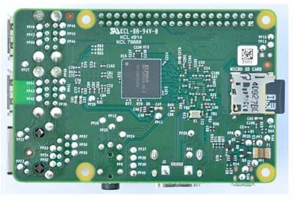

Fig 1.4.1: Raspberry Pi 3 MicroSD Card Slot

Connect the Raspberry Pi with a display monitor using HDMI Cable, a keyboard and a mouse. Power on the board by connecting to a power adaptor. The red LED on the board will start blinking and the OS will start booting from the MicroSD card. The boot process will display on the monitor and once the boot is complete, green LED will light up on the Raspberry Pi. After successfully installing Raspbian OS on Raspberry Pi, it is recommended to perform software update.

Web Service is an API. An API provide the data for application consume. But the web services is not about provide ‘’ Files Maintenance for web sites“ and it is not about whether or not a service is provided from one host or many.

Web Service provide functionality and act as an application over the web which can work without cloud environment. Cloud Services is a service is any service mode available to user on demand via Internet.

IoT is the most emerging and powerful technology which has changed our life Now a days the organization use IoT devices to collect real time and continuous data But collected data need to be processed and transferred in appropriate format to store an storage system.

The Raspberry pi act as a webserver ,and it has to store data generated from the IoT and this data grows exponentially, it forces to think about cloud storage for storing data

**CHAPTER 2**

**LITERATURE SURVEY**

MINSEOK JEON, SUN-KYUM KIM [1] present to” SEAMLESS FILE SHARING FOR ANDROID DEVICES”. They present an application of SFS which is applicable to various Android devices. Our application could be a solution for frequent disconnection of P2P file sharing in mobile devices. Since SFS doesn’t use the server, there are no additional communication costs. All users need the simple operation done by themselves. SFS will be extended to send and receive files at the same time. And it can improve the limitation of devices such as low battery or lack of capacity. We expect that our research will also be useful for related studies with regard to a variety of situations for seamless transfer.

**DISADVANTAGE**

Lack of security.

High power consumption

BYUNG MOO LEE [2] suggest a “MULTI-POINT MEDIA CONTENT SHARING SCHEME IN INTERNET OF THINGS NETWORKS”. In this paper, They proposed a multi-point content delivery scheme in IoT networks. Among three media sharing schemes, content redirection is the promising scheme that transfers the burden of mobile terminal to Sink. However, one of the issues that needs to be resolved using the content redirection is securing high link quality. Generally, AP and Sink are installed randomly, and users are not aware of the situation. They proposed a multi-point transmission scheme that can solve this problem, and can signiﬁcantly increase the performance of content redirection. There are two modes in the proposed scheme, power combining and bandwidth aggregation, and the two modes can be adaptively used depending on situations .The proposed scheme can be widely used to give high beneﬁt for both manufacture and end-users as a core technology of the IoT.

**DISADVANTAGE**

Difficult to send high quality multimedia services.

Content redirection is failed when the distance between ApSink exceeds 10m

CHIN-CHIH CHANG and WEN-XIANG WU [3] develop a **“**DISTRIBUTED FILE SHARING USING WEB SERVICES”. In this paper they have presented the architecture and mechanisms for sharing files across different platforms using RESTful Web services. The system is validated by experiments. From our research it shows that APIs designed by REST are concise and flexible. RESTful Web services can be used to implement a distributed files system which is cross-platform and not hindered by firewalls.

**DISADVANTAGE**

The proposed distributed file mechanisms are feasible and facilitate the transfer of small files.

By moving data to the server ,backup cannot be achieved.

DONGO and ATIK [4] present “DISTRIBUTED FILE SYSTEM FOR NDN: AN IOT APPLICATION”. In this paper, they discussed fully distributed approach of distributed file system and computation distribution based on NDN architecture applied to IoT. We showed through the use of simulations that the approach helps to mutualize the infrastructure utilization by distributing the computation among the edge nodes and avoid redundant computation. Our next task will be an analysis to discover the main factors driving the system. This analysis will be done using a sensitivity analysis.

**DISADVANTAGES**

The system only transmits minimal number of packages. It can only transmit files which are stored on the particular folder.

We must specify the path of the folder. The files are in other folders can’t transmit.

CHUAN LIN [5] suggested “SCHEDULING FOR TIME-CONSTRAINED BIG-FILE TRANSFER OVER MULTIPLE PATHS IN CLOUD COMPUTING”. In this paper, we have studied the SFTS and MFTS problems in cloud computing. For SFTS problem, we adopted maximum flow over time issue and auxiliary graph technique, to propose a heuristic and an exact algorithm, respectively. Simulation results show that both of our proposed algorithms can solve the SFTS problem. Especially, the heuristic can solve the SFTS problem efficiently although the exact algorithm can achieve better QoS, e.g., the transfer delay. For MFTS problem, we proposed a heuristic with an intelligent scheme which can maximize the throughput and schedule the multi-file flow dynamically, by solving the maximum multi-file flow over time problem. Simulation results show that our algorithm schedules the multi-file flow dynamically and can achieve high network utilization. Possible future work that can be derived from this work is designing traffic engineering strategy for files with different priorities.

**DISADVANTAGE**

It takes more processing time.

Highest cost

Loss of data while transfer

TIPAPOR JUENG CHARE ON POON [6] presented “A MOBILE CLOUD SYSTEM FOR ENHANCING MULTIMEDIA FILE TRANSFER WITH IP PROTECTION”. Currently, multimedia retrieval is very popular over the mobile device according to high technology of smartphone. In order to provide a good service, multimedia player software usually downloads full content of the media to the buffer before playing to users. Unfortunately, this process causes along delay for users and the transferring speed might be interrupted or terminated. Moreover, the multimedia server must have a large load if there are many persons concurrently download the files. In order to solve overloading problem and the long latency situation, the STEM is implemented. The segmentation of the media file is proposed and individually installed on each mobile devices of the cloud, which are member devices of the multimedia system provider. The installation of each segment is randomly selected with agreement from the device owner. As the result of using the STEM, the media segments will be transferred to the mobile client with a small latency. Furthermore, after finishing the play, the presented segment will be erased immediately; the buffer must contain the current playing segment only. Therefore, the intellectual property right is protected since no one can obtain the full copy of the media file. Additionally, there source allocation management over the mobile cloud system has been maintained effectively.

**DISADVANTAGE**

There are some side channel attacks possible to retrieve the shared key during the communication between IoT device and IoT server.

**CHAPTER 3**

**SYSYTEM ANALYSIS**

**3.1 EXISTING SYSTEM**

Web file transfer refers to a variety of services that allow users to share files over the web for other people to download. These services are often available for free, though users who want to share very large files may have to pay a fee to do so or for faster file transfers. web service is used for sharing files across different platforms. Web services can be used to implement a distributed files system which is cross-platform and not hindered by firewalls. A client will request Web services API through URI and the service sends the response back according the request method.A number of services offer the ability to transfer files over the web. They are marketed to people who want to share large files as email services usually place limits on the size of attachments. Web-based sharing services allow users to share videos and pictures easily.

Web file transfers typically employ the HTTP or HTTPS or XMPP protocols and hence are virtually immune to most firewall issues. The business model of these services is to offer a free tier with the ability to pay for the ability to upload larger files. Other sites might throttle the download rate for free users and offer faster transfers for paid accounts.

Cloud file sharing, also called cloud-based [file sharing](https://searchmobilecomputing.techtarget.com/definition/file-sharing) or online file sharing, is a system in which a user is allotted storage space on a [server](https://whatis.techtarget.com/definition/server) and reads and writes are carried out over the Internet. Cloud storage providers such as Drop box, Box, etc. for a secure file sharing can directly.

Cloud file sharing provides end users with the ability to access files with any Internet-capable device from any location. Usually, the user has the ability to grant access [privileges](https://whatis.techtarget.com/definition/privilege) to other users as they see fit. Although cloud file sharing services are easy to use, the user must rely upon the service provider ability to provide high availability ([HA](https://searchdatacenter.techtarget.com/definition/high-availability)) and [backup](https://searchdatabackup.techtarget.com/definition/backup) and [recovery](https://searchdisasterrecovery.techtarget.com/definition/data-recovery) in a timely manner.

As [cloud service providers](http://www.levelcloud.net/2014/12/how-to-choose-a-cloud-service-provider/) take care of a number of clients each day, they can become overwhelmed and may even come up against technical outages.

Although cloud service providers implement the best security standards and industry certifications, storing data and important files on external service providers always opens up risks

.

They demonstrate the informational security in a database implemented on the cloud servers and secure file sharing among them. File sharing is implemented separately in both web service and cloud storage .There is no combination of web service and cloud storage under IoT .

In addition the Zigbee technology is ideal in an IoT environment for creating personal area network. The Zigbee Protocol is one of the most popular standard for Wireless Sensor Networks. The Zigbee is commonly used in industrial IoT applications. Network developed by these Xbee modules are called personal area networks or PANs. Each network is defined with a unique PAN identifier (PAN ID). This identifier is common among all devices of the same network. ZigBee supports both a 64-bit and a 16-bit PAN ID. Both PAN addresses are used to identify a network uniquely. Devices on the same ZigBee network must share the same 64-bit and 16-bit PAN IDs. If multiple ZigBee networks are operating within range of each other, each should have unique PAN IDs. Zigbee is used to create a network. But, It is less secure compared with IoT secured system. IT operates on short range only (10-100m). It has certain limitation in the area of memory size and processing speed of data. To overcome these problem , We are using a raspberry pi, Pi is a cheap way of setting up virtual private network that stay online without consuming a large amount of power, It is small and powerful enough to handle a few connection at a time making it great for private use.

**3.2 Proposed System**

Here the new system is propose that called as IoT computing environment.ie, IoT in cloud offers public cloud services can easily help the IoT environment by providing third party access to the infrastructure. Hence, the integration can help IoT data (or) computational components operating over an IoT devices.

To create a small IoT computing environment for education system.(i.e. college) In college the students and staffs are connected with same network .If staff want to share any file they have to upload those files on server. Then the students can download those files and also students upload their files (Assignment). These all actions are permitted within particular time period.

It is enough to upload files on server only once. Repeated files are not allowed. There is no need to create a group for sharing files. The people who are authenticate person ,they can do anything.

First , the students and staffs are connected with the particular network(Wi-Fi). Students and Staffs are give their details on registration form. That will stored on the database. The person who want to share files (or) download files first fill the login form. Then, the details are checked by unique id and password. if he/she is a authorized person then they will allow to share or download files.

The session mechanism is used for a quite while without any problem. Then, create a hash from a combination of session start time and the person login username /hashed password and use it for all future request to the server. The session hash should be stored in the database upon the first request.

After the login procedure we can download /upload the files from the local machine to the desktop of the remote session when the session upload/download are enabled . Php will track the uploads/download of individual files being upload/download.

The Staffs as well as Students can have the ability to view the uploaded report of the assignments or any other files. The download/upload progress will be available in the “$ session” superglobal When an upload/download is in progress , and when parsing a variable of the same name as the session. Upload name INI setting is set to.

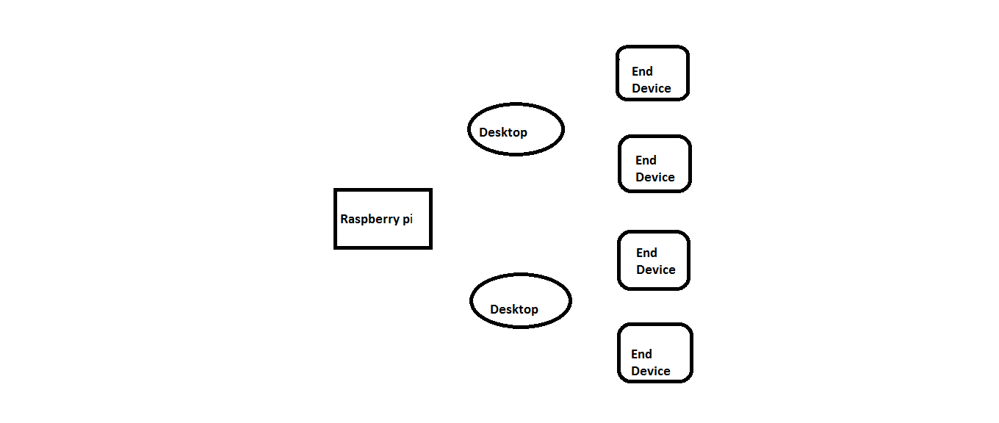

**Figure** **3.2.1: Block Diagram**

**Advantages**

To find if the students are present or not (attendance scheme)

Transfer the file in the secure manner.

Strong connectivity with students and staff and Share any type of attachments

**CHAPTER 4**

**SYSTEM DESIGN**

**4.1 SYSTEM ARCHITECTURE**

**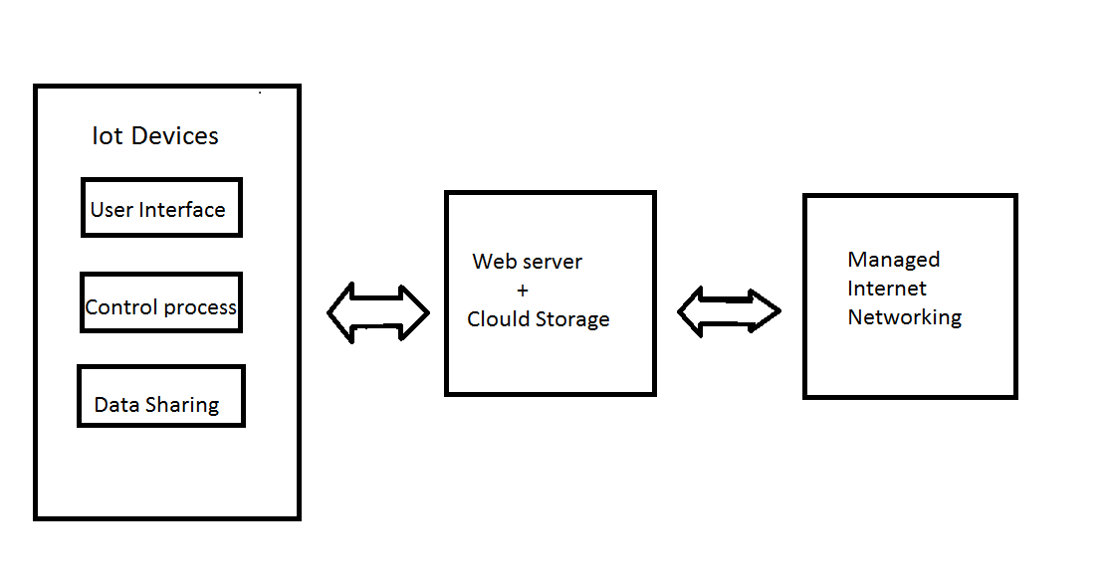**

**Managed intranet networking**

intranet

DB

**Figure 4.1.1: Architecture Diagram**

**ARCHITECTURE EXPLANATION**

IoT environment is created by connecting all IoT Devices with same network (Wi-Fi).If they connected with any other network , the apache server not allow to access anything. First, we have to set the default IP address and port number of the particular network on apache server configuration file so the devices which are connected on the network have the permission for file sharing.

User interface means by which the user and a computer system interact ,in particular the use of input devices and software. Here, the login and registration forms are created using html and php. The details which are given in registration form are stored on database. When the person submit the login form, it will check the database if the details(unique id and password) are already exits then only allow the user for download/upload. In upload process there is a session period. For example students want to submit their assignment ,

they can upload those files within that session period. otherwise ,they cant do that. Web server was implemented using XAMPP. It uses Apache to create a web server which works on local network without any need to access internet. It also provides features to create database using MySQL.

This database is then used to store all records. In our approach, we designed a user friendly website. The website requires users to Login or if they do not have an account they can registered using registration form.

The details of individuals having accounts are saved in a MySQL database. This website features include viewing files categorized (ie. Pictures, pdf, ppt, jpeg) It also incorporate uploading multiple files and downloading files Furthermore, it allows controlling devices based on Time conditions.

The files can be uploaded using the website itself or from the Android Application or through the Desktop Application. This website also enables users to view the list of files. Website is developed in PHP, a server side scripting language, html to provide a user friendly interface.

**CHAPTER 5**

**UML DIAGRAMS**

**5.1 USECASE DIAGRAM**

A use case diagram is a dynamic or behavior diagram in UML. Use case diagrams model the functionality of a system using actors and use cases. Use cases are a set of actions, services, and functions that the system needs to perform .

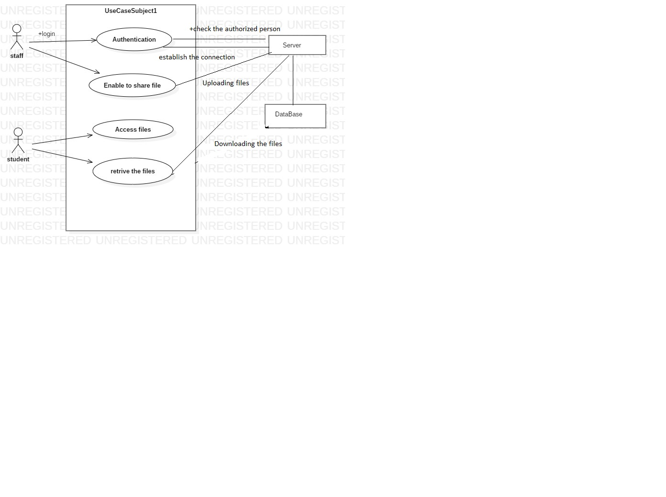

Figure 5.1.1 : Use case Diagram

**5.2 ACTIVITY DIAGRAM**

Activity diagram is another important diagram in UML to describe the dynamic aspects of the system. Activity diagram is basically a flowchart to represent the flow from one activity to another activity...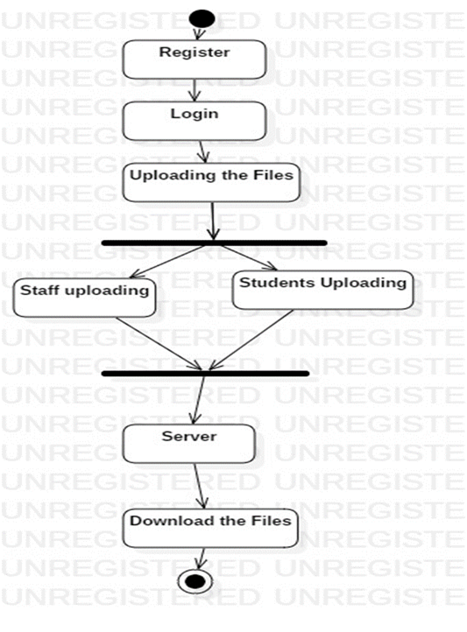

Figure 5.2.1 : Activity Diagram

**5.3 COLLABARATIVE DIAGRAM:**

A collaboration diagram, also called a communication diagram or interaction diagram, is an illustration of the relationships and interactions among software objects in the Unified Modeling Language.

**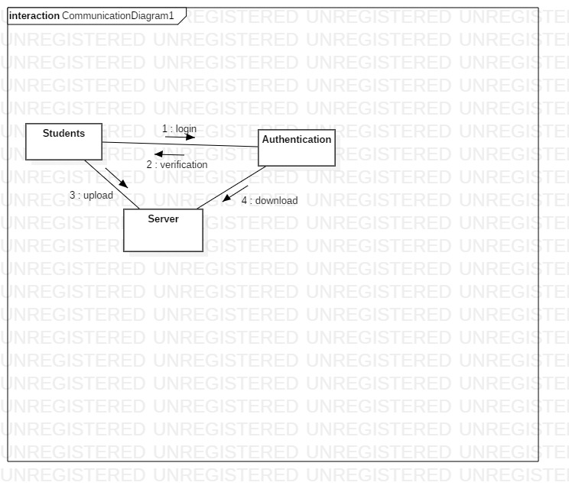**

**Figure 5.3.1 : Collabarative Diagram for Students**

**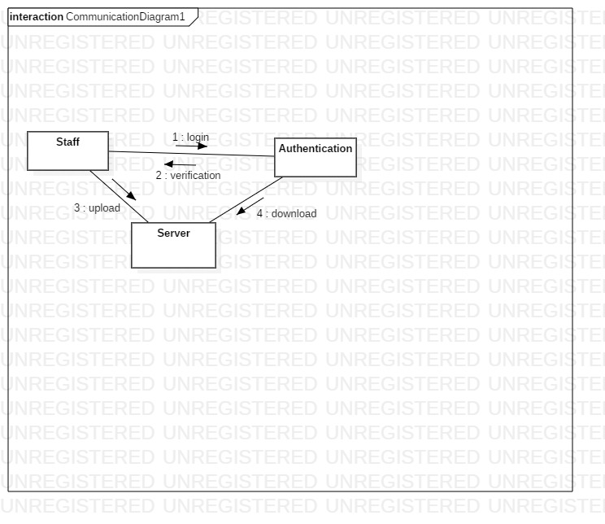**

**Figure 5.3.2 Collabarative Diagram for Staff**

**5.4 SEQUENCE DIAGRAM**

A sequence diagram simply depicts interaction between objects in a sequential order i.e. the order in which these interactions take place. We can also use the terms event diagrams or event scenarios to refer to a sequence diagram. Sequence diagramsdescribe how and in what order the objects in a system function.

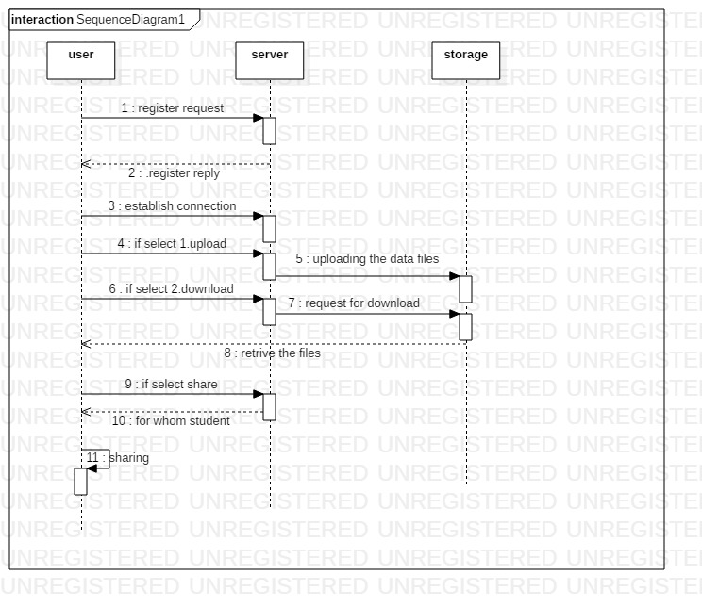

**Figure 5.4.1 Interaction Diagram for files upload**

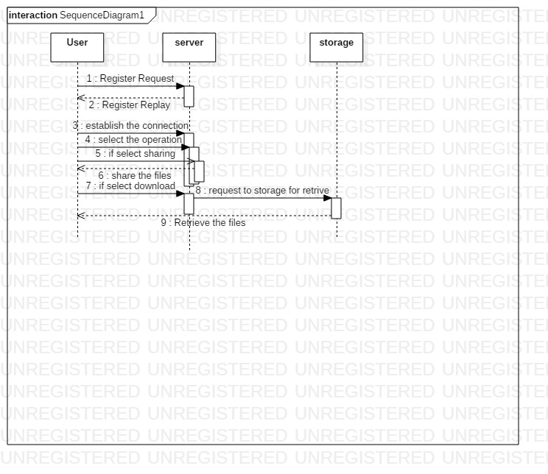

Figure 5.4.2 : Interaction Diagram for files download.

**CHAPTER 6**

**SYSTEM REQUIREMENTS**

**6.1 HARDWARE REQUIREMENTS**

The hardware requirements may serve as the basis for a contact for the implementation of the system and should therefore be a complete and consistent specification of the whole system.

Hardware - Raspberry pi

Storage - 16gb

**6.2 SOFTWARE REQUIREMENTS**

The software requirements provide a basis for creating the software requirements specification .

Operating System - Raspbian OS [Raspberry pi] & windows

Front End - HTML

Back End - PHP, MYSQL

Software - XAMPP Server

**CHAPTER 7**

**SYSTEM IMPLEMENTATION**

**7.1 Module specification**

A. VPN Environment Creation

B. IoT Device Authentication

C. Session Allocation

D. Android and Desktop application

* 1. **Module Description**

1. **VPN Environment Creation**

We believe that the evolution towards the Internet of Things will eventually result in the creation of a Programmable World in which even the simplest things and most ordinary artifacts are connected to public or private clouds and can be controlled and programmed remotely. The possibility to connect, manage, configure and dynamically reprogram simple devices through the cloud will enable a huge variety of new use cases, services, applications and device categories, and will open up entirely new product families and ecosystems

1. **IoT device Authentication**

Regardless of authentication method IoT security is the aim .We may decide two-tier factor authentication is sufficient. User Name and Password have been the main method of authentication. We may wish to use Azure IoT to manage all devices.

1. **Session Allocation**

Session is a way to store information to be used across multiple pages. Unlike a cookie the information not stored on the user computer. In this module session is used for assignment submission of student. We can upload the file within particular time period which is allocated by staffs. Within that time period the students can upload files aft.er that time period the uploading page will be closed. you can’t upload anything.

The session is used for each and every action of the students.

The session time is generate for :

* Student login
* Uploading their assignment
* Downloading the files

Login page is open for particular time period (for example 9 to 5).Within

that time student will login the page ,and upload their assignments. As well as, if staff uploads their files, students will download that within that required period . After the completion of the time no one can upload, download or view anything.

1. **Android and Desktop application**

To allow users having android based smartphones\tablets and desktop computer/laptop an easy and user friendly access to the application. This application saves users from the trouble of logging in every time they have to visit the website and allows using website on the move. These files are then stored on an application specific directory created when the application is installed. It provides file synchronization service i.e. mirroring files on the server.

**CHAPTER 8**

**SYSTEM DESIGN AND IMPLEMENTATION**

**PHASE 1 :** **Steps for creating Virtual Host**

To create a virtual private network, we should install VPN server on raspberry pi

**Setting up a Raspberry Pi VPN Server:**

**Step 1 :** First, install PiVPN, this handles all the grunt work for setting up a VPN and reduces the potential for making mistakes. We should first change the password of the default pi user.

Passwd

**Step 2 :** With the password changed we can begin the process of setting up our VPN server on the Raspberry Pi. We can begin this process by running the command below, this command downloads the install [PiVPN script.](https://github.com/pivpn/pivpn" \t "_blank)

curl -L https://install.pivpn.io | bash

**Step 3:** To proceed to the next screen, we just need to press enter.

**Step 4:** The next screen explains that it will need to set up a static IP address for the Raspberry Pi, this is so that when the Raspberry Pi is restarted for any reason, it will try and utilize the same IP address again.

**Step 5:** On here we will just be selecting **<Yes>** to using the current network settings as a static local IP Address. If the current settings is ok , then select **<No>**.

**Step 6 :**  Just select **<Ok>** and press enter.

**Step 7 :** Here we will be presented with a list of users that we can choose. Press

enter.

**Step 8** : This setting helps secure the Raspberry Pi which is incredibly important since we will be opening a port on the router. Select <Ok> to continue.

**Step 9**: On this screen, we highly recommend selecting **<Yes>**. Leaving this feature switched off can pose a significant security risk to your Raspberry Pi and potentially our network.

**Step 10** : Select the protocol TCP or UDP

**Step 11** : select the port OpenVPN and press <e**nter>** to retain the default port of <**1194**>, and we do recommend changing this.

**Step 12:** The confirmation screen for the port number is set and choose  **<Yes>** to continue.

**Step 13:** choose the encryption key size, and we recommend using “**2048-bit encryption”** as it currently offers good protection without sacrificing speed.

**Step 14 :** Select OK and to proceed. If the client software supports 2.4, then select <No>.

If client does support OpenVPN 2.4, make sure to select <yes>.

**Step 15 :** we want to make use of Dynamic IP service such as **no-ip.org**.

**Step 16** :  The next step is to select a DNS provider. A DNS provider is what resolves a URL into an IP address.

**Step 17 :**  Now successfully completed the installation .

**Step 18 :** Now be greeted by a screen asking for us to reboot the Raspberry Pi, just select **<Yes>** .

**PHASE 2: CREATE A SERVER FOR DATA TRANSFER**

**Step 1: Install Raspbian**

Install Raspbian using an SD card, just as you would for any other Raspbian-based project. For a refresher on OS installation, head over to our post on how to install Raspbian on the Raspberry Pi.

**Step 2: Install Apache**

Before installing the server, make sure we have an up-to-date machine. To do this we must have administrator rights, either because of the sudo command.

sudo apt update

sudo apt upgrade

sudo apt update

Once the Raspberry Pi is up to date, we will install the Apache server.

sudo apt install apache2

By the way, we’ll take advantage of it to give rights to the apache file that you can easily manage your sites. To do this, run the following commands:

sudo chown -R pi:www-data /var/www/html/

sudo chmod -R 770 /var/www/html/

**Step 3: Install MySQL**

We need MySQL, a database management system, to store and manage the data for our site. As with apache, MySQL is installed with a couple of easy lines in the terminal.

sudo apt-get install mysql-server

During the installation, we should set a root password (leaving the spot blank means you’ll have no password).

sudo mysql\_secure\_installation

In this stage we have the option to change your root password. Since you only just set it, Say yes to everything else.

**Step 4: Install PHP**

We’re finally at the end of our acronym! PHP is responsible for the dynamic content of our site. Back to the terminal, now, with this

command:

sudo apt-get install php-fpm php-mysql

Let’s edit a file. These are PHP’s settings, and we’re going to make it more secure.

sudo nano /etc/php/7.0/fpm/php.ini

Find the line that says #cgi.fix\_pathinfo=1 and change it to cgi.fix\_pathinfo=0. find it with the search function (Ctrl +W). Then exit with Ctrl +X and

save with Y.

Then restart PHP:

sudo systemctl restart php7.0-fpm

**Add PhpMyAdmin**

The installation of PhpMyAdmin is absolutely not necessary. In this installation, we will not take care about any special security settings !

The PhpMyAdmin installation is pretty quick and easy, we simply have to use the packet manager with this command :

sudo apt install phpMyAdmin

**PHASE 3: CONNECTING WITH DATABASE**

The database is a *MySQL* database, not a *phpMyAdmin* database. phpMyAdmin is only PHP code that connects to the DB.

MySQL connect('localhost', 'username', 'password') or die (MySQL error());

mysql\_select\_database('db\_name') or die (MySQL error ());

**PHASE 4 : SESSION MECHANISM**

The session is the system or way to store information for individual users. It’s storing individual users information against a unique session ID. So in this way, user’s data can be accessible across all pages of a website. PHP follow simple workflow for manage session, and that is when a session is started, then PHP either retrieve existing session or create a new session. If **PHPSESSID** is passed then PHP retrieved existing session otherwise creates a new session. By default, session creates a file in a temporary directory (which determi2ned in php.ini file) on a server. All the variables & value are stored there.

s

**$session [‘user id’] = 1234**

User id=’1234’

User name=abc

Session id : 67457248

Every user is able to access only their session. The session can be stored on the server, or on the client. If it’s on the client, it will be stored by the browser, most likely in cookies and if it is stored on the server, the session ids are created and managed by the server. So if there are a million users connected to the server, there will also be a million session ids for those users on the server.

**WORKING PRINCIPLE OF SEESION**

A single user application, like a desktop application, there is only one user, so there is also one session, it is not difficult for the application to make the connection between the user and their session data. As the client, give the server our session id, and in return the server grants so we can access to our session data if it finds our session id stored in its session data store.

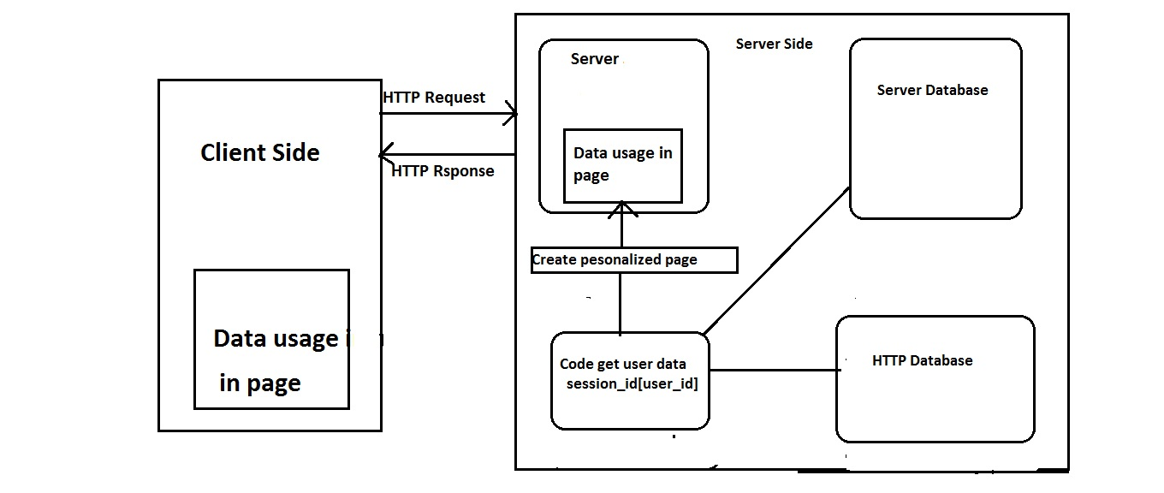

**Figure 8.1 : Working module of session**

When we receive a webpage from the server, along with the page content itself, the server sent (in general, in a cookie) the session id that it set to identify our connection among all the requests that it gets. After we logged in, the application validated your password and login and saved your user id in the session so that every time we will make a request, we won’t have to log in again (this will be detailed later).

**1** – We send a http request to the server asking for the drafts (file uploading or downloading) page. Along with this http request send our session id to the server. The session id is usually sent in cookies, but it can also be sent in GET or POST parameters, whatever the technique the session id just needs to be sent to the server.

**2** – The server receives your request. Before it gives our drafts page, it checks our session id, looks it up in its session datastore.

**3** -The server then executes the code corresponding to your request .

**4** – The code starts by getting your user id from the session made available by the server earlier, then it uses it to ask the database “for the corresponding request who has this user id”.

**5** – Finally when the code got our files from the database, it creates an html page, and hands it to the server.

**6** – The server sends what we request along with our session id.

A session gets destroyed when the user closes the browser or leaves the site. The server also terminates the session after the predetermined period of session time expires.

**PESUDO CODE**

$\_SESSION["user"] = "Sachin";   // store the information

echo $\_SESSION["user"];  // Get information

echo $\_SESSION["user"]; //session start

 <?php

session\_start ();

?>

<html>

<body>

<?php

$\_SESSION["user"] = "Sachin";

echo "Session information are set successfully.<br/>";

?>

<a href="session2.php">Visit next page</a>

</body>

</html>

File 2: session . php

<?php

session start();

?>

<html>

<body>

<?php

echo "User is: ".$\_SESSION["user"];

?>

</body>

</html>

// PHP Destroying Session

PHP session\_destroy()

*File: session3.php*

<?php

session\_start();

session\_destroy();

?>

**PHASE 4 : FILE SHARING**

**File Uploading :**

**index.php**//connect to database  
//get information from form (Register id, name, password)  
//submit query to add information from form  
//if query is successful  
//--session started  
//if failed  
//--print error message  
//disconnect from database

**upload. php**  
//browse the files locally  
// specifies the directory where the file is going to be placed

//file specifies the path of the file to be uploaded

// $uploadOk=1 then file uploaded

//disconnect from database  
  
**Download.php**

//connect to server (topic database)  
//display the file   
//select the file   
//file can be download.

**#logout . php**

// connect to db

// store the list of operation

// disconnect to db

**CHAPTER 9**

**RESULT & DISCUSSION**

**Graphical Representation**

**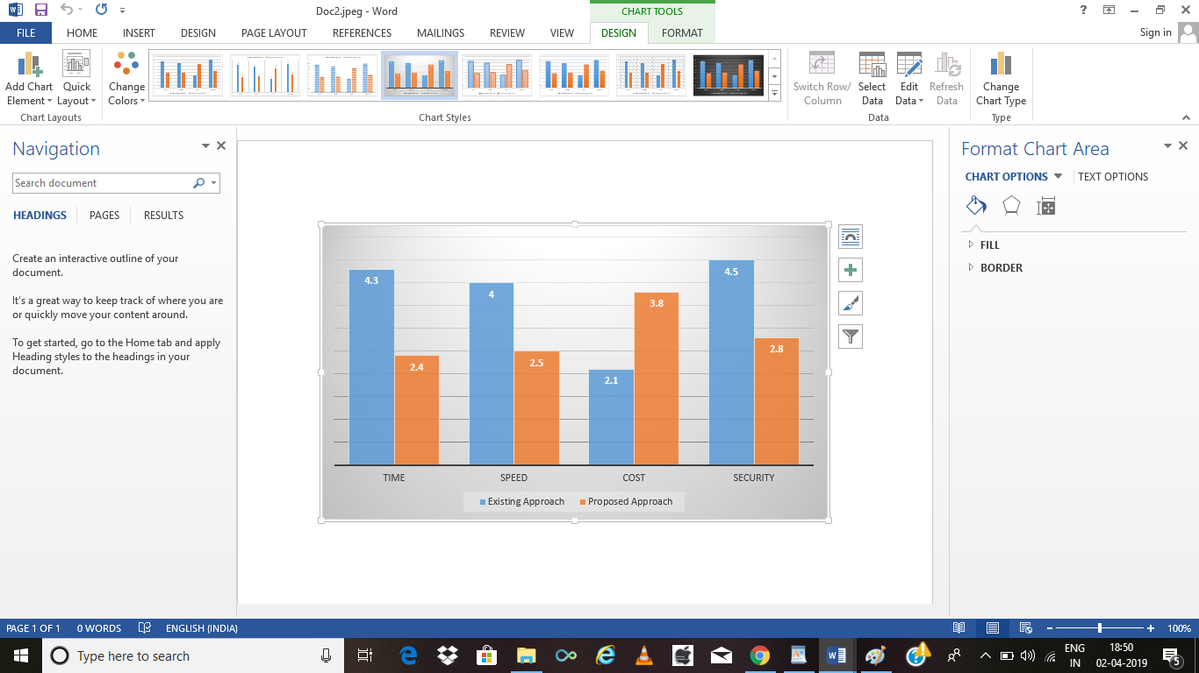**

In above graph representation is advantageous especially with respect to existing approach.

**INSTALLING XAMPP SERVER**

**Apache Installation :**

**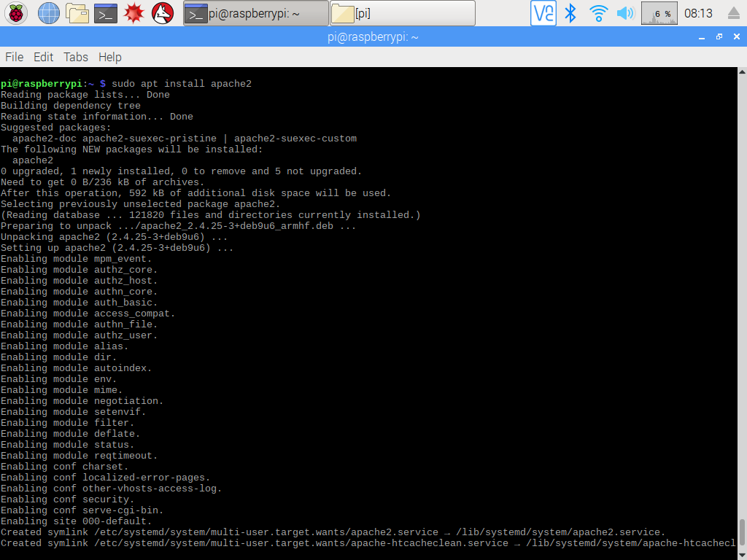**

**MySQL Installation:**

**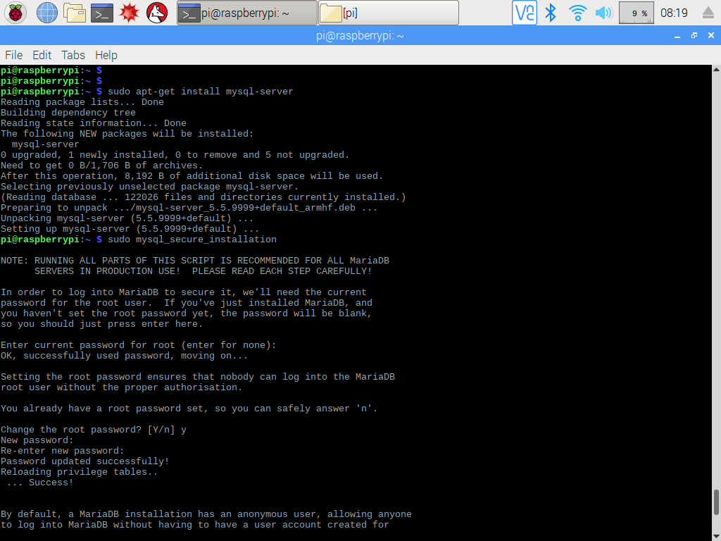**

**PHP Installation:**

**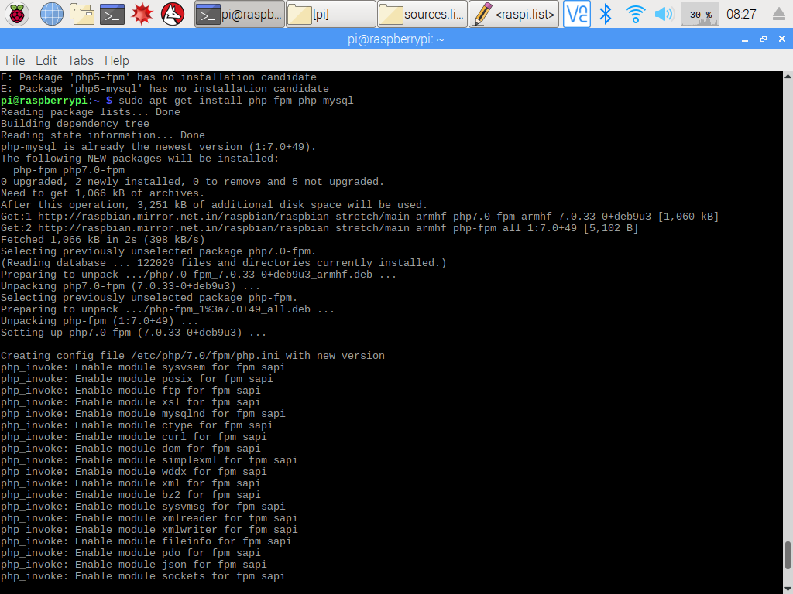**

**Login**

**Figure 8.1**

**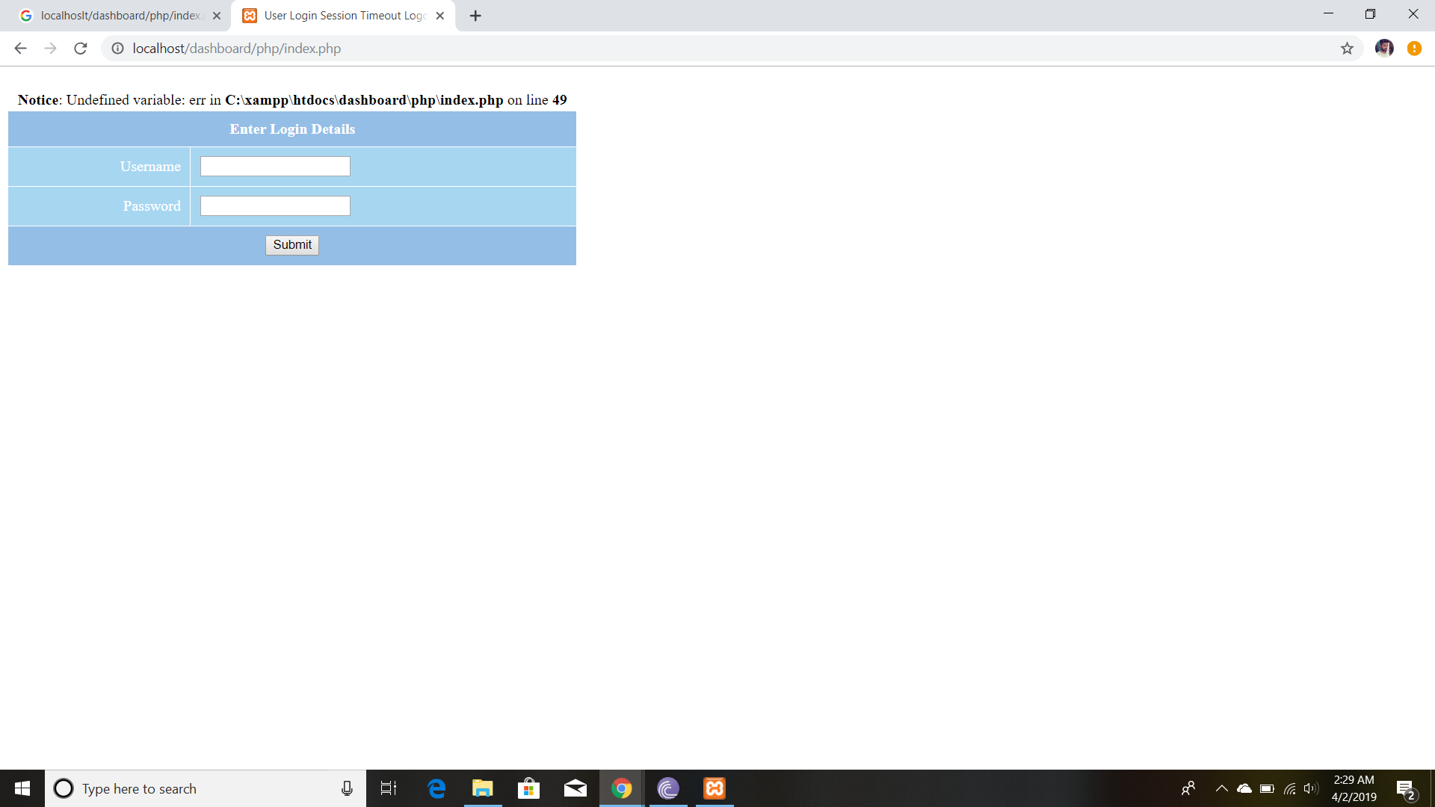**

**User Login Page**

**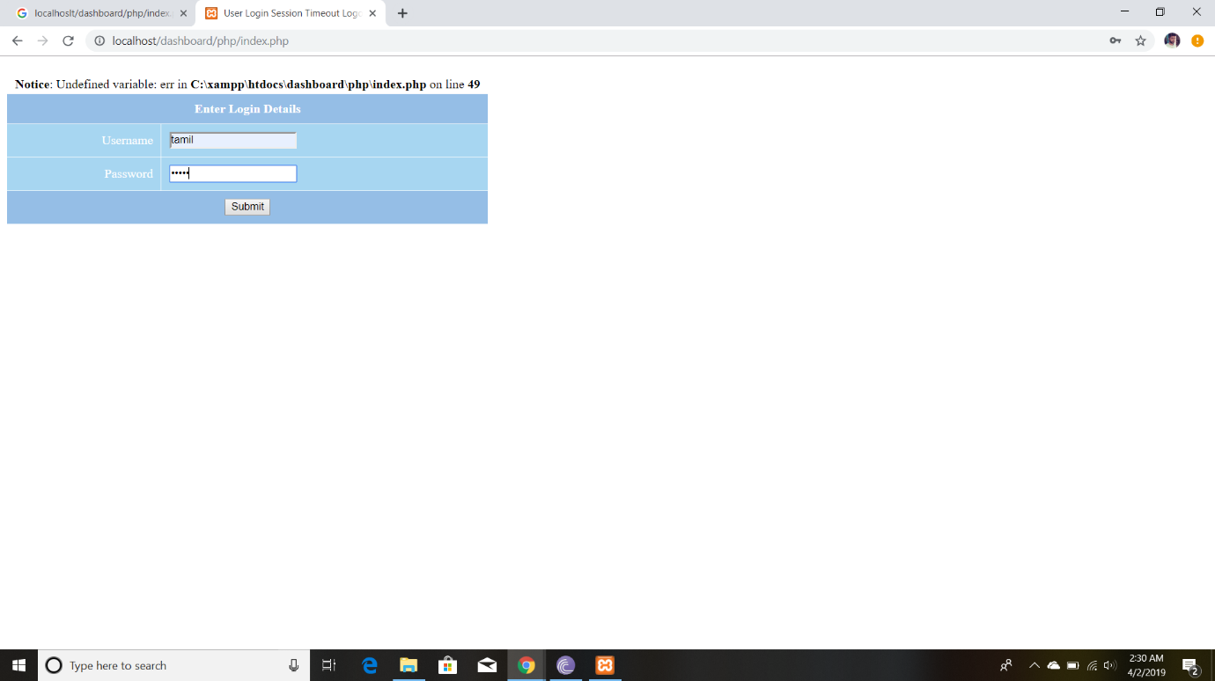**

**user enter the details**

**File Sharing :**

**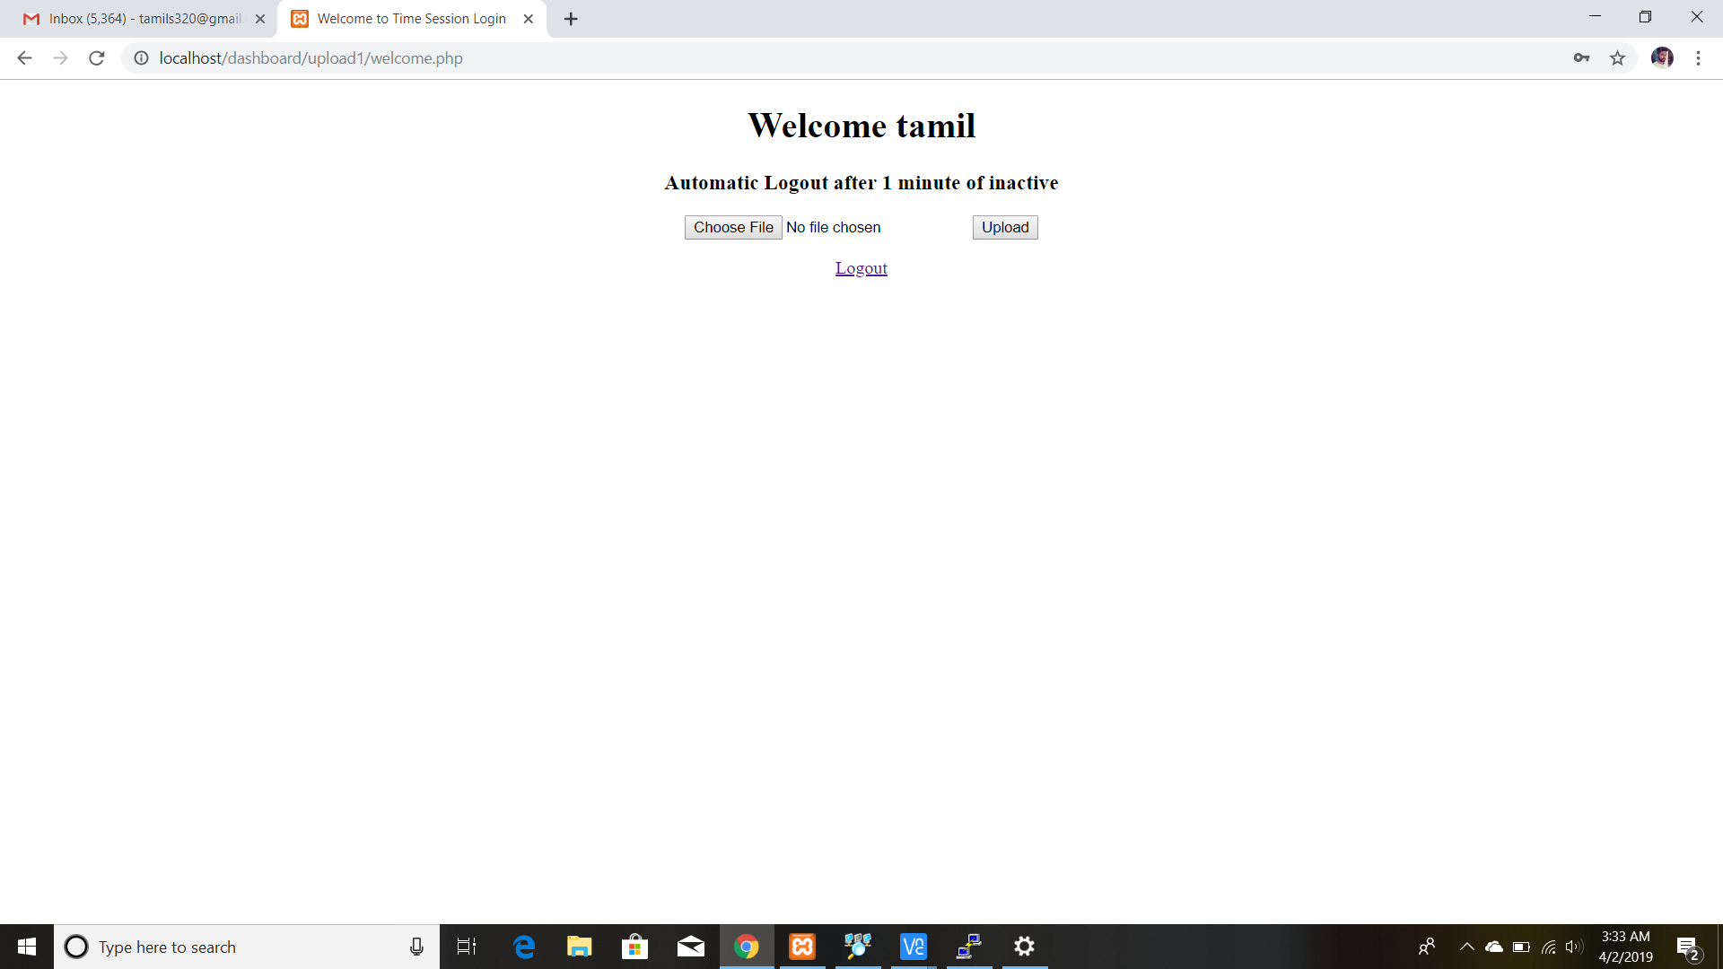**

**File upload page**

**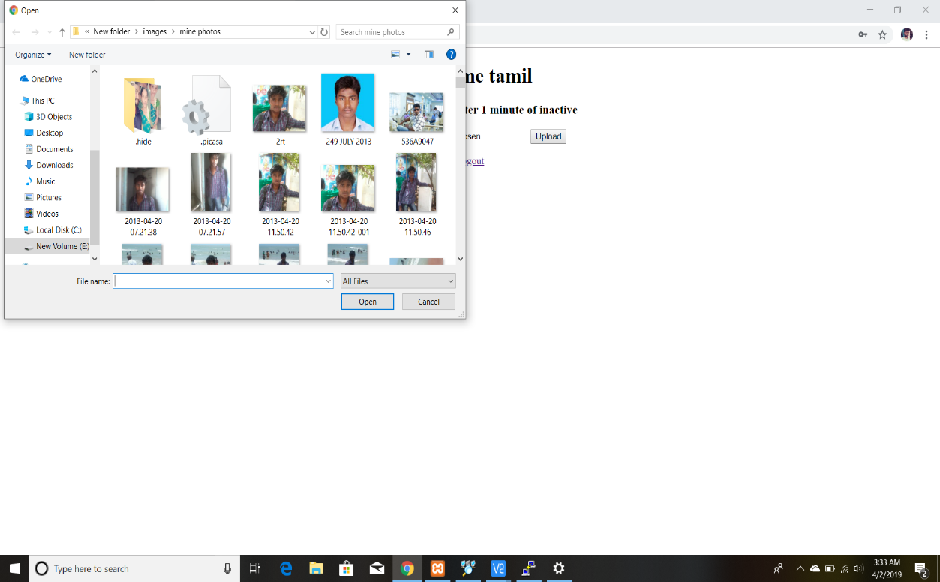**

**Browse the file**

**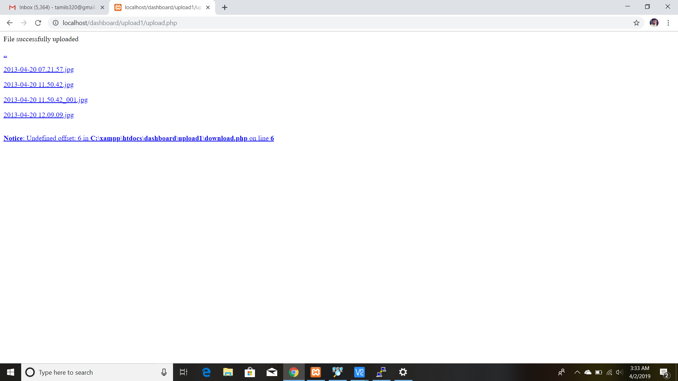**

**File was uploaded**

**CHAPTER 10**

**CONCLUSION**

This document a new concept of Enterprise Solution. The research about the cloud computing and Internet of Things (loT) is the main motivation for this paper. The modules which are implemented in this work facilitate an Enterprise by reducing the human effort. The Local Host Web Server is the center of everything in this project.

Every module, directly , is connected to the web server. So a single person can control the devices connected within the range of LAN. All these modules have worked perfectly for a LAN environment. Currently, So that the project can meet the needs of real life applications. On small scale i.e. on LAN networks the project can be implemented as it is. If Proper Hardware is designed for specific Industrial Applications, the more proper implementation can be done with online web hosting. Which will help revolutionizing the industry. This thesis has the part in fourth generation Industrial Revolution.

**CHAPTER 11**

**REFERENCES**

1. “Google Cloud Messaging for Android - Android Developers.” [Online]. Available: http:// developer.android.com/google/gcm/index.html
2. “Local and Push Notification Programming Guide: Apple Push Notification Service.”
3. [Online].Available:http://developer.apple.com/library/mac/\#document ation/NetworkingInternet/Conceptual/RemoteNotificationsPG/ApplePush Service/ApplePushService.html
4. R. Piyare, "Internet of things: ubiquitous home control and monitoring system using android based smart phone", International Journal of Internet of Things 2013
5. L Paul, M Dirk, B Andre. HashFS: applying hashing to optimize file systems for small file reads [A]. Proceedings of the International Workshop on Storage Network Architecture and Parallel I/Os. USA:IEEE,2010.33-42.
6. A M Maria, H L Sergio , S Abel, et al. A comparative study of data storage and processing architectures for the smart grid [A]. Proceedings of the First IEEE Interantional Conference on Smart cloud Communications. USA:IEEE,2010.285-290
7. [M D Francesco, Li Na, M Raj, et al. A storage infrastructure for heterogeneous and multimedia data in the Internet of things[A]. Proceedings of the 2012 IEEE Internatioanl Conference on Onternet of Things. USA:IEEE,2012.26-33.v
8. Zhang Yang and Liu Dan. Improving the efficiency of storing for small files in HDFS [A]. Proceedings of the International Conference on Computer Science & Service System. USA:IEEE,2012.2239-2242
9. Kothmayr, T., Schmitt, C., Hu, W., Brünig, M., & Carle, G. (2012, October). A DTLS based end-to-end security architecture for the Internet of Things with two-way authentication. In Local Computer Networks Workshops (LCN Workshops), 2012 IEEE 37th Conference on (pp. 956-963). IEEE..
10. Khemissa, Hamza, and Djamel Tandjaoui. "A lightweight authentication scheme for e-health applications in the context of internet of things." Next Generation Mobile Applications, Services and Technologies, 2015 9th International Conference on. IEEE, 2015.
11. Conway, Gerry, "Introduction to cloud computing". White Paper. IVI: Innovation Value Institute, National University of Ireland Maynooth, 2011.